PROJECT DOCUMENTATION

- Title :- Boston Housing Feature Engineering .

Submitted By :- Sujal Sudhakar Salvi .
Course :- Data Analytics .
Submitted To :- Prajakta Tayde .

- Introduction :-
This document describes the preprocessing and feature engineering steps performed on the Boston Housing dataset using Python. The main goal of this work is to clean the data, create meaningful features, and prepare the dataset for house price prediction using machine learning models.

- Objectives :-
- To explore and understand the Boston Housing dataset.
- To clean and preprocess the data for better quality.
- To apply feature engineering to create meaningful features.
- To prepare the dataset for house price prediction using machine learning.

- Dataset Description :-
Dataset Name :- Boston Housing .

Description :- The Boston Housing dataset contains information related to housing, environmental conditions, and socio-economic factors of different areas in Boston.
The target variable in this dataset is MEDV, which represents the median value of owner-occupied houses.

- Column Description :-
- crim (Crime Rate per Capita) :-
This column shows how much crime happens in an area. A higher value means the area has more criminal activity, which can negatively affect house prices.

- zn (Zoning Percentage for Residential Land) :-
This represents the percentage of land that is reserved for large residential houses. Higher values usually indicate more planned and spacious residential areas.

- indus (Proportion of Non-Retail Business Area) :-
This column shows how much land is used for industrial or business purposes. Areas with more industries may be noisier and less preferred for housing.

- chas (Charles River Dummy Variable) :-
This tells whether a house is located near the Charles River. A value of 1 means it is near the river, and 0 means it is not.

- nox (Nitric Oxide Concentration) :-
This indicates the level of air pollution in the area. Higher values mean more pollution, which can reduce the quality of living.

- rm (Average Number of Rooms per House) :-
This column shows the average number of rooms in houses of that area. Houses with more rooms are generally larger and more expensive.

- age (Proportion of Old Houses) :-
This represents the percentage of houses built before 1940. Higher values mean the area has older houses.

- dis (Distance to Employment Centers) :-
This shows how far the houses are from major job locations. Smaller values mean better access to workplaces.

- rad (Index of Highway Accessibility) :-
This indicates how easily highways can be accessed from the area. Higher values mean better road connectivity.

- tax (Property Tax Rate) :-
This column represents the amount of property tax charged in the area. Higher tax rates increase the overall cost of owning a house.

- ptradio (Pupil–Teacher Ratio) :-
This shows the number of students per teacher in schools nearby. Lower values usually indicate better education quality.

- lstat (Lower Status Population Percentage) :-
This represents the percentage of people from lower-income groups. Higher values often indicate less developed areas.

- medv (Median Value of Owner-Occupied Houses) :-
This is the target column of the dataset. It shows the median price of houses in the area.

- Dataset Analysis :-

- Visualization of House Price Distribution :-

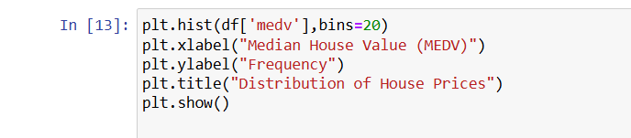
Explanation :- This code creates a histogram to show how house prices are distributed in the dataset. The x-axis represents the median house values, while the y-axis shows how many houses fall into each price range. By dividing the prices into multiple bins, the graph helps us see where most house prices are concentrated and whether the data contains very low or very high values. This visualization is useful for understanding the overall pattern of house prices and for identifying possible skewness or extreme values in the data.

- Relationship Between Number of Rooms and House Price :-
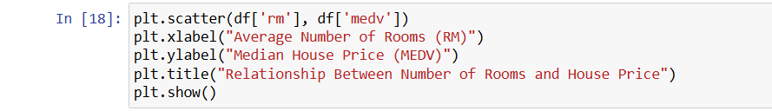
Explanation :- This visualization is used to understand how house prices change with respect to the number of rooms. The x-axis represents the average number of rooms per house, while the y-axis shows the median house price. Each point in the scatter plot corresponds to an individual house. From the graph, it is clearly observed that an increase in the number of rooms is usually associated with higher house prices. This relationship highlights the importance of house size as a key factor influencing property value. The insights from this graph justify the feature engineering steps where room-related attributes are used to enhance the dataset for better price prediction.

- Feature Engineering: Price per Room :-
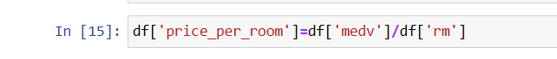
Explanation :- This code creates a new feature called price per room by dividing the median house value by the average number of rooms. This feature helps in understanding how much value is associated with each room of a house. Instead of looking only at total house price, this calculation gives a normalized measure, which makes it easier to compare houses of different sizes. Such derived features often improve model performance by capturing more meaningful patterns from the data.

- Feature Engineering: Tax per Room :-

Explanation :- This code generates a new feature named tax per room by dividing the property tax value by the average number of rooms. It helps to understand how much tax is associated with each room in a house. This makes it easier to compare tax burden across houses of different sizes. By normalizing tax with respect to room count, this feature provides a more meaningful representation and can help improve the accuracy of further analysis or prediction models.

- Feature Engineering: Room–Distance Interaction :-
Explanation :- This code creates a new feature called room distance by multiplying the average number of rooms with the distance to employment centers. This interaction feature captures the combined effect of house size and location. It helps to analyze how larger houses located farther or closer to workplaces influence house prices. Creating such interaction features allows the model to understand relationships between multiple factors more effectively.

- Conclusion :-
In this project, the Boston Housing dataset was analyzed and prepared using feature engineering techniques. The data was explored, visualized, and enhanced by creating new meaningful features such as price per room, tax per room, and room–distance interaction. These newly derived features help in better understanding the relationship between house prices, size, location, and taxation.Visual analysis, like the house price distribution, provided useful insights into the overall pattern of the target variable. Feature engineering played an important role in improving data quality and making the dataset more informative for further modeling. Overall, the preprocessing steps made the data clean, structured, and suitable for building accurate machine learning models for house price prediction.

